US 3rd Army Dispersed
47
MILITARY


3rd US 1ST CAN
If US 3rd ARMY has not entered Brittany, invoke “3rd ARMY DIVERSION” rule, otherwise advance as normal

AIR POWER
JABOS: +1 1st CAN
RESOURCES
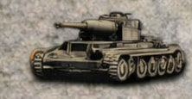
1 x Kampfgruppe* Lose 1
*Deploy to map or Strategic Reserve for 1 action

ORDERS: 4 Actions
-1 Defense Value 3rd US Army
With the garrisons at Brest, Lorient and St Nazaire continuing to hold out, plus the 2nd French \armored Division was increasingly keen to extricate itself from the Falaise battle with the liberation of Paris in mind. 3rd Army’s problems were further exacerbated by its divisions moving further away from their supply bases.

